Hands-on 3:

Spring Core and Maven

Exercise 1: Configuring a Basic Spring Application:

File name: pom.xml

<project xmlns="http://maven.apache.org/POM/4.0.0"

xmlns:xsi="http://www.w3.org/2001/XMLSchema-instance"

xsi:schemaLocation="http://maven.apache.org/POM/4.0.0

http://maven.apache.org/xsd/maven-4.0.0.xsd">

<modelVersion>4.0.0</modelVersion>

<groupId>org.example</groupId>

<artifactId>Library_Management</artifactId>

<version>1.0-SNAPSHOT</version>

<name>Archetype - Library_Management</name>

<url>http://maven.apache.org</url>

<properties>

<maven.compiler.source>1.8</maven.compiler.source>

<maven.compiler.target>1.8</maven.compiler.target>

<spring.version>5.3.32</spring.version> <!-- Latest 5.x version -->

</properties>

<dependencies>

<!-- Spring Core -->

<dependency>

<groupId>org.springframework</groupId>

<artifactId>spring-core</artifactId>

<version>${spring.version}</version>

</dependency>

<dependency>

<groupId>org.springframework</groupId>

<artifactId>spring-context</artifactId>

<version>${spring.version}</version>

</dependency>

<dependency>

<groupId>org.springframework</groupId>

<artifactId>spring-beans</artifactId>

<version>${spring.version}</version>

</dependency>

<dependency>

<groupId>org.springframework</groupId>

<artifactId>spring-expression</artifactId>

<version>${spring.version}</version>

</dependency>

<dependency>

<groupId>junit</groupId>

<artifactId>junit</artifactId>

<version>4.13.2</version>

<scope>test</scope>

</dependency>

</dependencies>

</project>

File name:applicationContext.xml

<?xml version="1.0" encoding="UTF-8"?>

<beans xmlns="http://www.springframework.org/schema/beans"

xmlns:xsi="http://www.w3.org/2001/XMLSchema-instance"

xsi:schemaLocation="http://www.springframework.org/schema/beans

http://www.springframework.org/schema/beans/spring-beans.xsd">

<bean id="bookService" class="com.library.service.BookService"/>

<bean id="bookRepository" class="com.library.repository.BookRepository"/>

</beans>

File name: BookRepository.java

package com.library.repository;

public class BookRepository {

public void saveBook(){

System.out.println("Book saved to repository");

}

}

File name: BookService.java

package com.library.service;

public class BookService {

public static void issueBook(){

System.out.println("Issued book from service..");

}

}

File name: Main.java

package com.library;

import com.library.service.BookService;

import org.springframework.context.ApplicationContext;

import org.springframework.context.support.ClassPathXmlApplicationContext;

public class Main {

public static void main(String[] args) {

ApplicationContext context =new ClassPathXmlApplicationContext("applicationContext.xml");

BookService bookService =context.getBean("bookService" , BookService.class);

BookService.issueBook();

}

}

OUTPUT: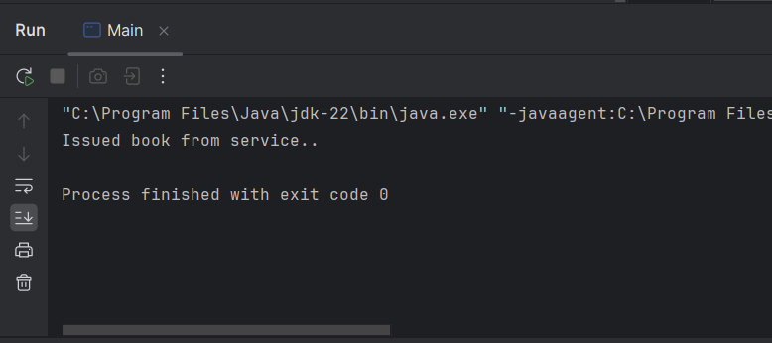

Exercise 2: Implementing Dependency Injection:

File name: applicationContext.xml:

<?xml version="1.0" encoding="UTF-8"?>

<beans xmlns="http://www.springframework.org/schema/beans"

xmlns:xsi="http://www.w3.org/2001/XMLSchema-instance"

xsi:schemaLocation="

http://www.springframework.org/schema/beans

http://www.springframework.org/schema/beans/spring-beans.xsd">

<!-- BookRepository bean -->

<bean id="bookRepository" class="com.library.repository.BookRepository"/>

<!-- BookService bean with dependency injected -->

<bean id="bookService" class="com.library.service.BookService">

<property name="bookRepository" ref="bookRepository"/>

</bean>

</beans>

File name: BookRepository.java

package com.library.repository;

public class BookRepository {

public void saveBook(){

System.out.println("Book saved to repository");

}

}

File name:BookService.java

package com.library.service;

import com.library.repository.BookRepository;

public class BookService {

private BookRepository bookRepository;

// Setter method for Dependency Injection

public void setBookRepository(BookRepository bookRepository) {

this.bookRepository = bookRepository;

}

public void issueBook() {

System.out.println("Issuing book from BookService..."); bookRepository.saveBook();

}

}

File name: Main.java

package com.library;

import com.library.service.BookService;

import org.springframework.context.ApplicationContext;

import org.springframework.context.support.ClassPathXmlApplicationContext;

public class Main {

public static void main(String[] args) {

ApplicationContext context = new ClassPathXmlApplicationContext("applicationContext.xml");

BookService bookService = context.getBean("bookService", BookService.class);

bookService.issueBook();

}

}

OUTPUT:

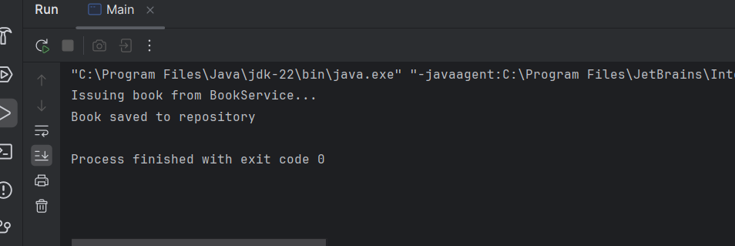

Exercise 4: Creating and Configuring a Maven Project

Add Spring Dependencies in pom.xml:

Include dependencies for Spring Context, Spring AOP, and Spring WebMVC.

File name: pom.xml

<project xmlns="http://maven.apache.org/POM/4.0.0"

xmlns:xsi="http://www.w3.org/2001/XMLSchema-instance"

xsi:schemaLocation="http://maven.apache.org/POM/4.0.0

<http://maven.apache.org/xsd/maven-4.0.0.xsd>"> <modelVersion>4.0.0</modelVersion>

<groupId>com.library</groupId> <artifactId>LibraryManagement</artifactId>

<version>1.0-SNAPSHOT</version>

<properties>

<java.version>1.8</java.version>

<spring.version>5.3.32</spring.version>

</properties>

<dependencies>

<!-- Spring Context -->

<dependency>

<groupId>org.springframework</groupId>

<artifactId>spring-context</artifactId>

<version>${spring.version}</version>

</dependency>

<!-- Spring AOP -->

<dependency>

<groupId>org.springframework</groupId>

<artifactId>spring-aop</artifactId>

<version>${spring.version}</version>

</dependency>

<!-- Spring Web MVC -->

<dependency>

<groupId>org.springframework</groupId>

<artifactId>spring-webmvc</artifactId>

<version>${spring.version}</version>

</dependency>

<!-- Optional: Servlet API (for web apps) -->

<dependency>

<groupId>javax.servlet</groupId>

<artifactId>javax.servlet-api</artifactId>

<version>4.0.1</version>

<scope>provided</scope>

</dependency>

</dependencies>

Configure Maven Plugins:

Configure the Maven Compiler Plugin for Java version 1.8 in the pom.xml file.

<project xmlns="http://maven.apache.org/POM/4.0.0"

xmlns:xsi="http://www.w3.org/2001/XMLSchema-instance"

xsi:schemaLocation="http://maven.apache.org/POM/4.0.0

http://maven.apache.org/xsd/maven-4.0.0.xsd">

<modelVersion>4.0.0</modelVersion>

<groupId>com.library</groupId>

<artifactId>LibraryManagement</artifactId>

<version>1.0-SNAPSHOT</version>

<properties>

<java.version>1.8</java.version>

<spring.version>5.3.32</spring.version>

</properties>

<dependencies>

<!-- Spring Context (Core container) -->

<dependency>

<groupId>org.springframework</groupId>

<artifactId>spring-context</artifactId>

<version>${spring.version}</version>

</dependency>

<!-- Spring AOP -->

<dependency>

<groupId>org.springframework</groupId>

<artifactId>spring-aop</artifactId>

<version>${spring.version}</version>

</dependency>

<!-- Spring WebMVC -->

<dependency>

<groupId>org.springframework</groupId>

<artifactId>spring-webmvc</artifactId>

<version>${spring.version}</version>

</dependency>

<!-- Servlet API for web-related tasks -->

<dependency>

<groupId>javax.servlet</groupId>

<artifactId>javax.servlet-api</artifactId>

<version>4.0.1</version>

<scope>provided</scope>

</dependency>

</dependencies>

<!-- Maven Compiler Plugin for Java 1.8 -->

<build>

<plugins>

<plugin>

<groupId>org.apache.maven.plugins</groupId>

<artifactId>maven-compiler-plugin</artifactId>

<version>3.8.1</version>

<configuration>

<source>${java.version}</source>

<target>${java.version}</target>

</configuration>

</plugin>

</plugins>

</build>

</project>